GCD:

In mathematics, the **greatest common divisor** (**gcd**) of two or more integers, when at least one of them is not zero, is the largest positive integer that divides the numbers without a remainder. For example, the **GCD** of 8 and 12 is 4.

LCM:

A common multiple is a number that is a multiple of two or more numbers. The common multiples of 3 and 4 are 0, 12, 24, .... The **least common multiple** (**LCM**) of two numbers is the smallest number (not zero) that is a multiple of both.

SOURCE CODE:

//Uclidean method:

#include<stdio.h>

void main()

{

int x,y ,t,a,b,gcd,lcm;

printf("enter two integers:\n");

scanf("%d %d",&x,&y);

a=x;b=y;

while(b!=0){

t=b;

b=a%b;

a=t;

}

gcd=a;

lcm=(x*y)/gcd;

printf("greatest common divisor of %d and %d=%d\n",x,y,gcd);

printf("least common multiple of %d and %d=%d\n",x,y,lcm);

}

OUTPUT:

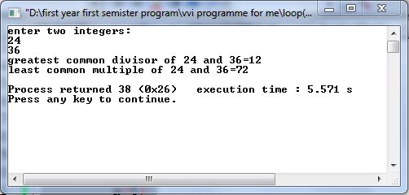

//by prime factorization

#include<bits/stdc++.h>

using namespace std;

int main(){

int i,j,tmp,m,n,gcd;

bool f;

cout<<"enter two values\n";

while(cin>>m>>n){

f=true;

j=sqrt(m);

gcd=0;

for(i=1;i<=j;i++){

if(m%i==0){

tmp=m/i;

if(n%tmp==0){

gcd=tmp;

f=false;

break;

}

}

}

if(f)

cout<<"gcd1= "<<1<<endl;

else

cout<<"gcd= "<<gcd<<endl;

}

return 0;

}

OUTPUT:

